FORD TRIMOTOR SPERRY GYROPILOT POH

References

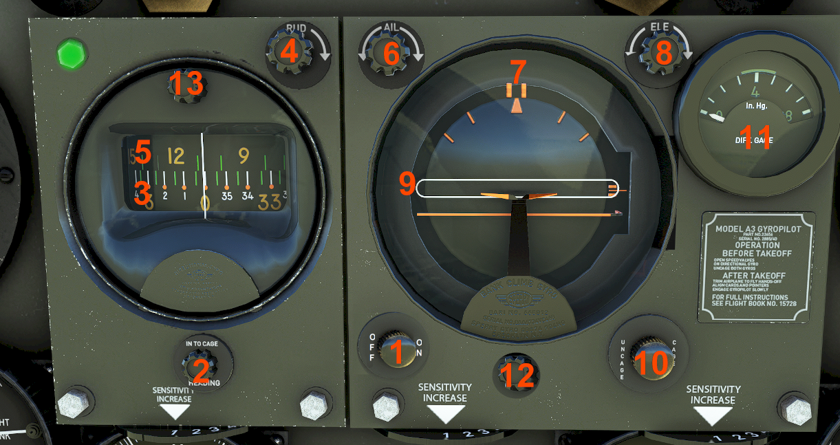

Index Name ____________________
(1) Power On/Off Button
(2) Gyro Drift Corrector
(3) Directional Heading Gyro Scale
(4) Rudder Knob (Heading Selector)
(5) Heading Bug Scale
(6) Aileron Knob (Bank Selector)
(7) Bank Bug
(8) Elevator Knob (Pitch Selector)
(9) Elevator Follow Up (Pitch Bug)
(10) Attitude Caging Knob
(11) Vacuum needle
(12) Plane Adjust Knob
(13) Gyroscope Lighting Knob

Operation
First time engaged
Configure the aircraft for a stabilized flight, correctly trimmed and wings leveled. Select the appropriate prop RPMS. Ensure that there is enough vacuum pressure, and the Attitude gauge is free (uncaged).
Select the heading bug position. If the new heading is to the left of current, rotate rudder knob (4) counterclockwise until heading bug scale (5) value coincides with the center white mark. Rotate (4) clockwise if new heading is to the right of current.
Select the desired bank (max 30 deg) by rotating the aileron knob (6) same direction to where the rudder knob (4) was rotated – counterclockwise for left bank and clockwise for right bank. Check that position of bank bug (7) coincides with desired bank to reach.
Turn gyropilot ON by pushing power button (1). Check that green light is ON to confirm the unit is active.
Aircraft will start turning towards the selected heading due to the gyropilot inputs to rudder and ailerons. Once reaching that heading, it will be maintained by keeping the wings leveled.
If a climb or descent is desired, slowly rotate the elevator knob (8) clockwise to pitch up (climb) and counterclockwise to pitch down (descend) until the VS gauge shows the rate expected. The pitch bug (9) will move up/down accordingly. Once close to reach the reference altitude, start repositioning the pitch bug up/down so to maintain zero VS at that level (bear in mind the gyropilot will not capture the selected altitude).

With gyropilot engaged
To start a new turn, just rotate the rudder knob (4) as needed to reposition the heading bug scale (5). The gyropilot will command the rudder for a shallow turn (coordination ball uncentered). If the new heading is close to the current, rudder input should be enough. For large heading changes, it will be necessary to add a bit of bank to speed up the turn (centered ball), then rotate the aileron knob (6) to position bank bug (7) as explained in previous paragraph. When the new heading is reached bank bug will auto reset to 0.
For climbs or descents use the same procedures described above.
Caging the Attitude gauge with the attitude caging knob (10) makes the gyropilot command an immediate wing leveled position, ignoring the heading and bank bugs (that are not auto reset). Uncaging the Attitude will make the gyropilot continue with the turn as it was commanded before.

Gyropilot Performance
Within turns, use bank bug with caution. Best results are obtained with bank angles between 10-15 degrees. When using max or close (20-30 deg), they should be manually reduced as current heading approximates to bug position, to avoid overshooting the target (there might be oscillations during the capture process).
When using rudder input only, the gyropilot will command a turn towards the smallest trackangle. However, when using the bank bug, direction of turn will depend on side of bank selected (left/right). An opposite bank bug will command an extended, uncoordinated turn, that might be useful in certain circumstances (for example, making a 360 degrees change).

